**Make it live!!!**

Start by going to <https://github.com/> and creating an account.

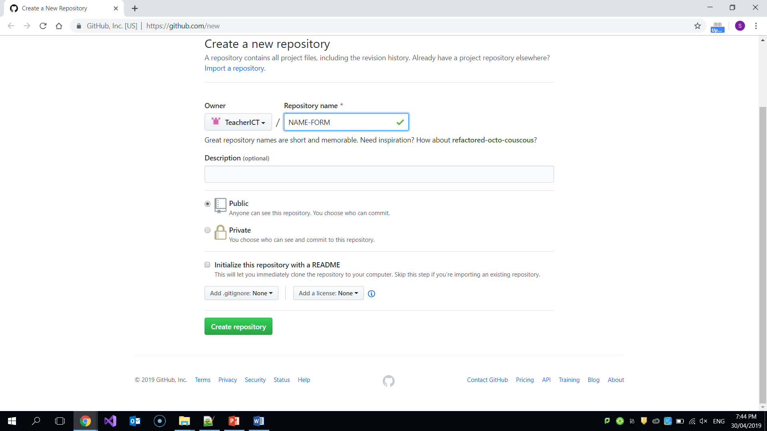

After creating an account, you will be prompted to create a repository. You will name the repository as YOUR_NAME-FORM.

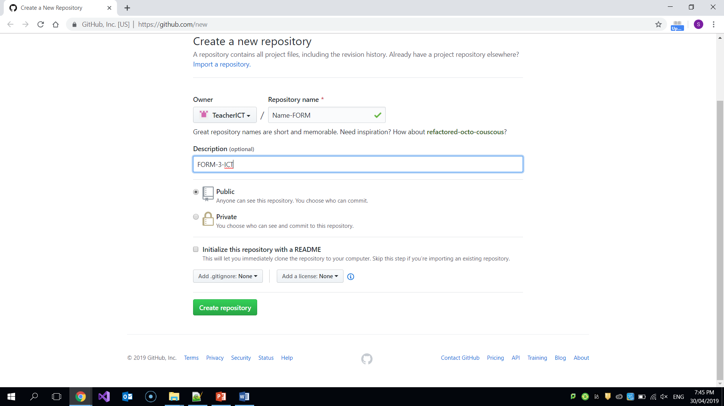

Set the Description to FORM-3-ICT. Make sure it is public and then press the Create repository button.

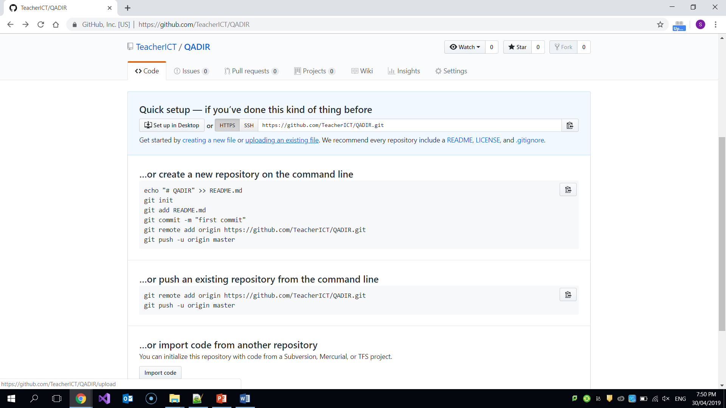

After pressing the Create repository button you will get this page. Select uploading an existing file.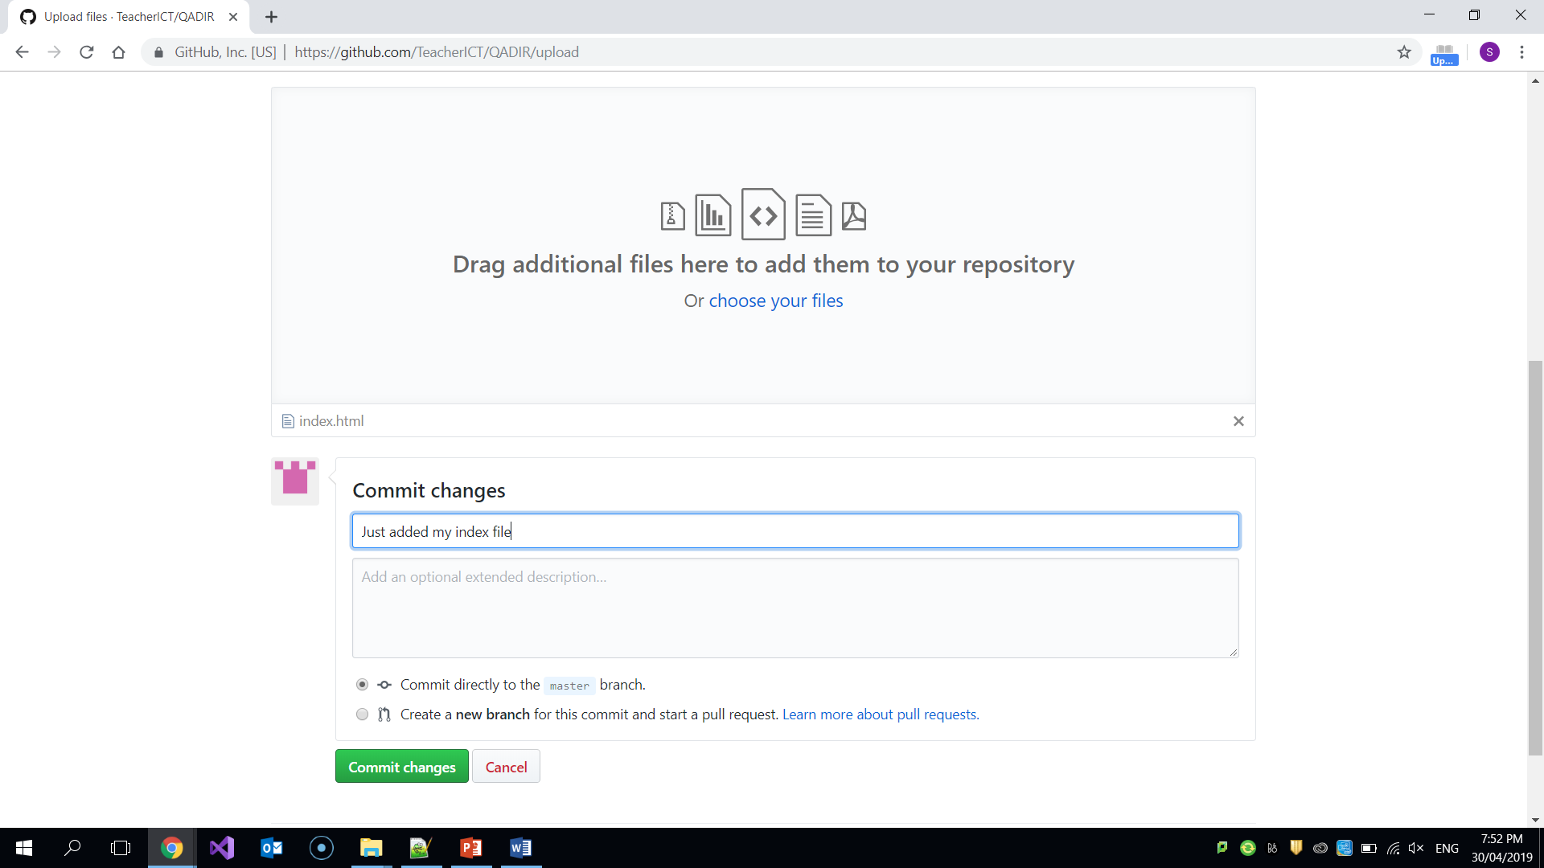Then you will get this page. In it you will choose your files. Get the files from your form-3-ict folder. Commit is where you put a note of what you have done or changes you have made. The usefulness of this become clearer when we do version control. Finally select commit changes.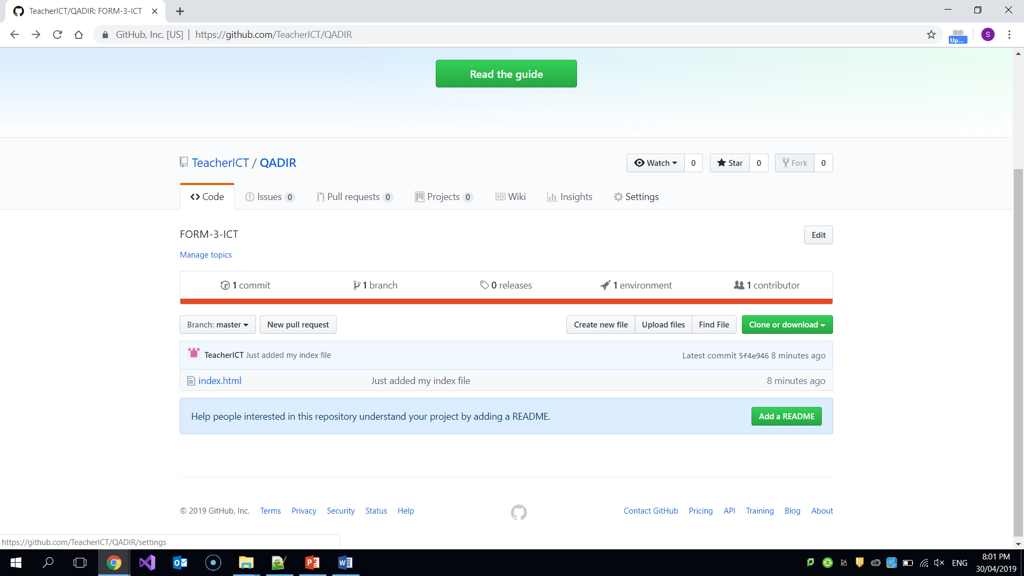

Now you will see this page. You should be able to view all the files that you have uploaded. Now select the settings tab.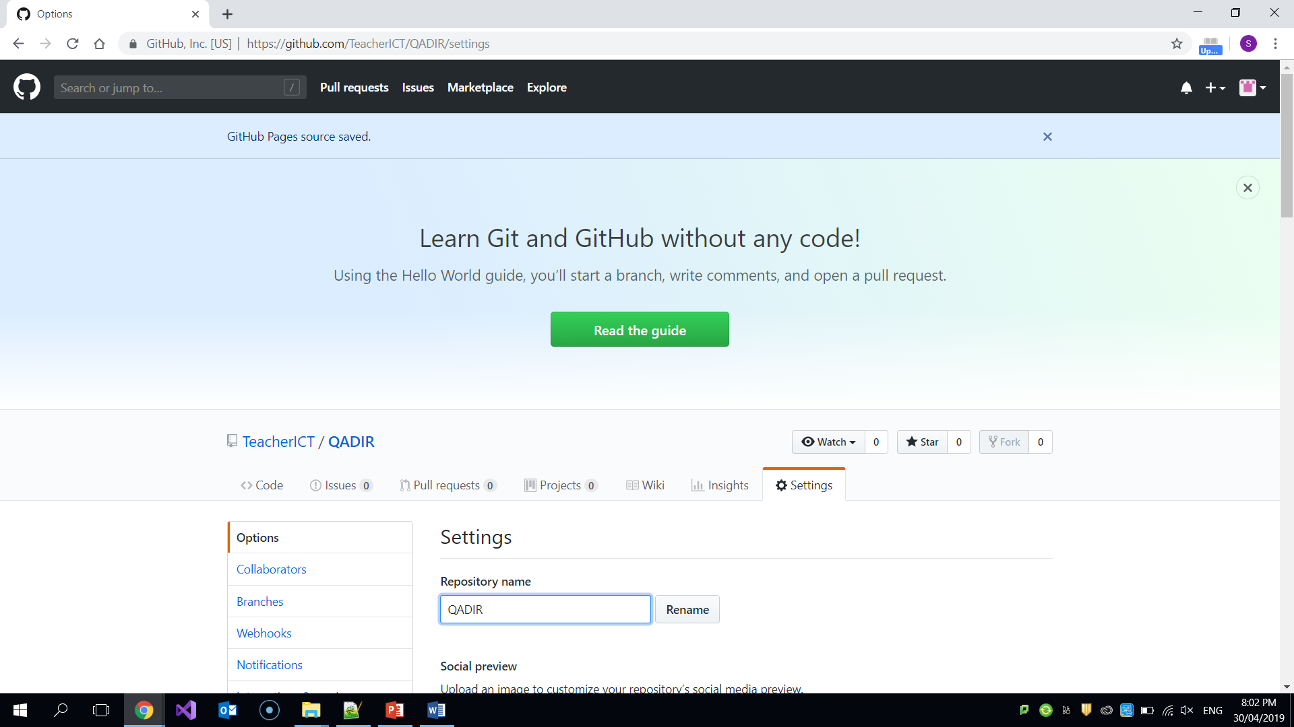In it you will give your repository a name. This will be your surname.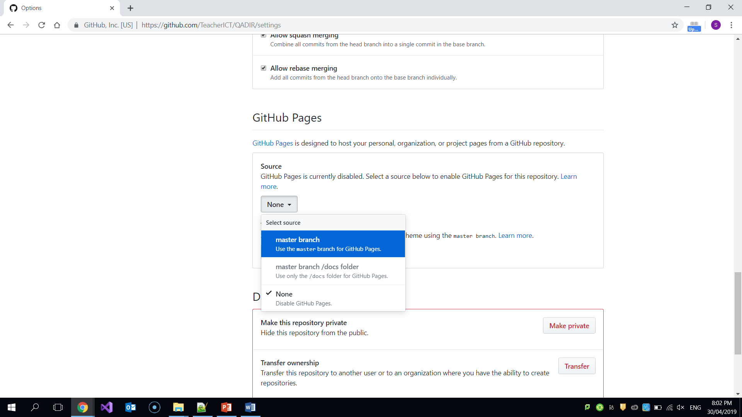If you scroll further down you will find GitHub Pages section. In it select the “master branch”. 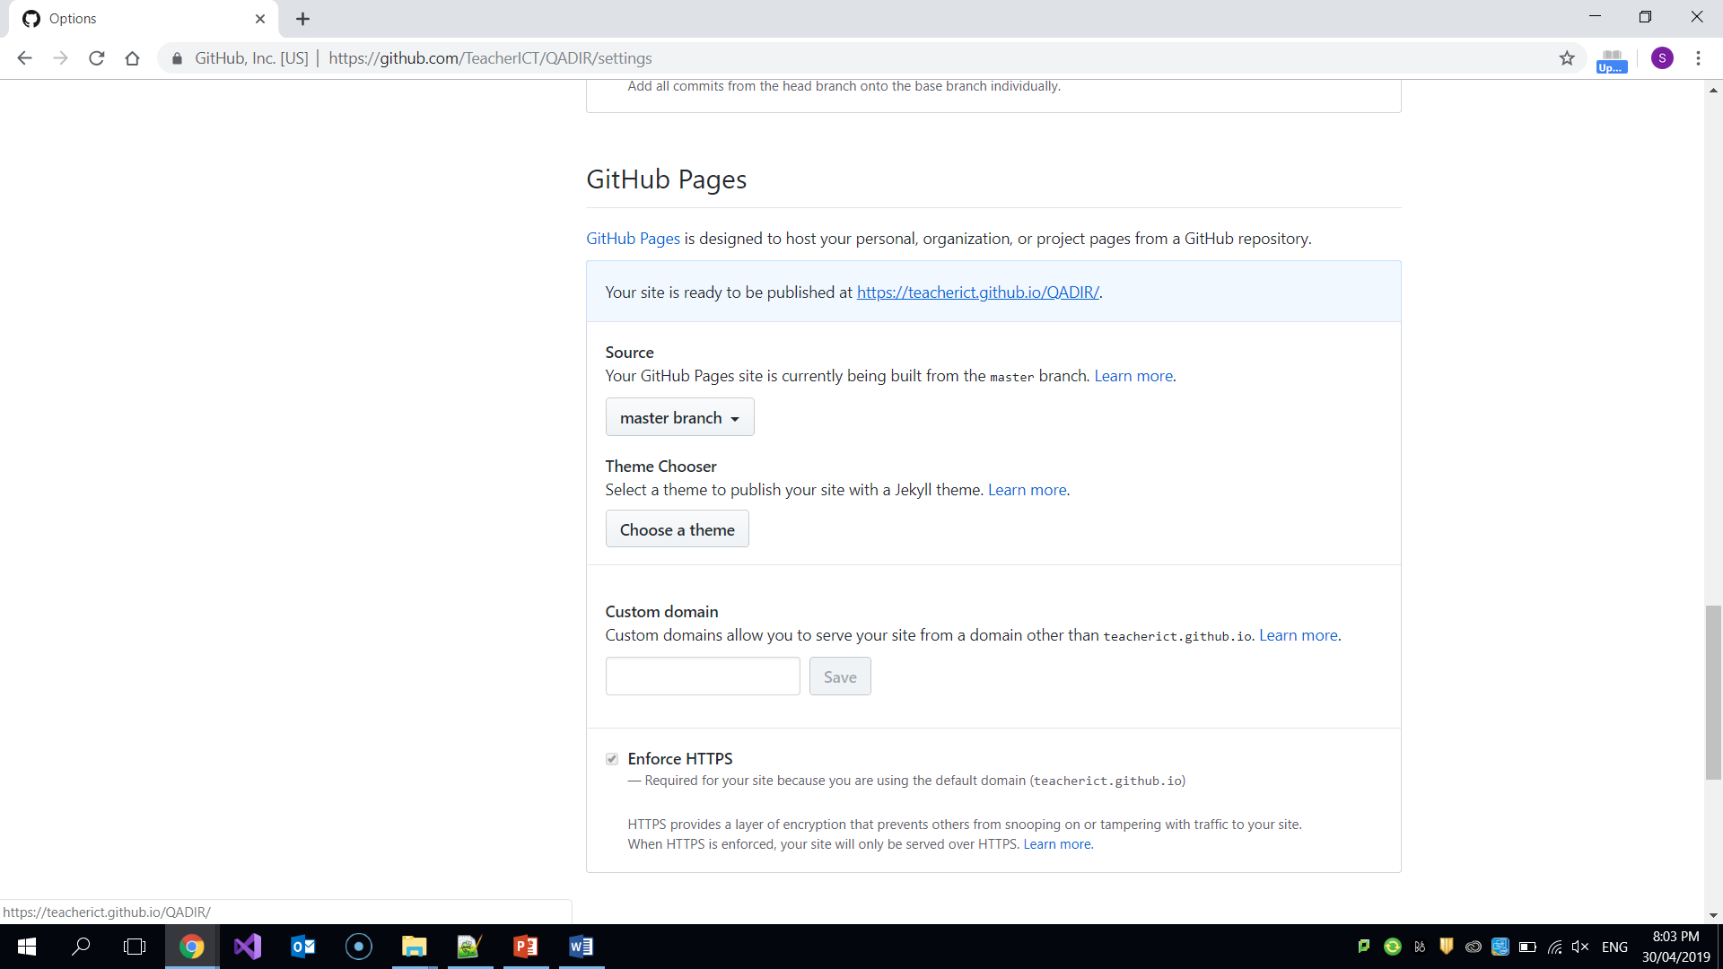Now you will be able to see a link generated. Clicking it will open your website. You share this link with anyone you like and they will also be to view your website.